Group BY: 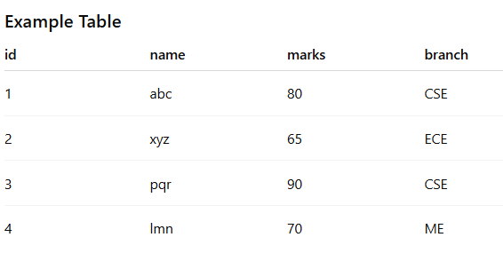
1.Select Count(id) As Total from students;
2.Select Max(marks) from students;
3. Select avg(marks) from students;
4.Select branch, Count(id) from students group by branch;
5. Select branch, max(marks) from students group by branch;

SQL JOIN:
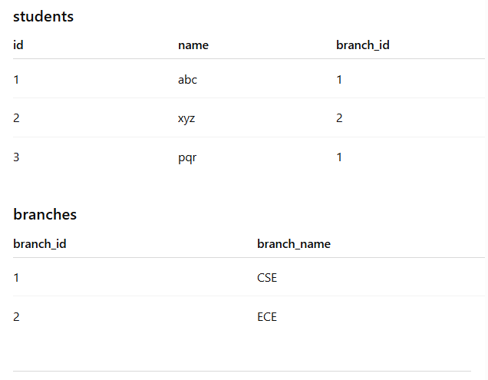
- Select s.name , b.branch_name from students as s inner join branches as b on s.branch_id=b.branch_id;
- Select count(s.id) , b.branch_name from students as s inner join branches as b on s.branch_id=b.branch_id group by branch_name;
- Select s.name, b.branch_name from students as s inner join branches as b on s.branch_id=b.branch_id order by s.name;

Having:

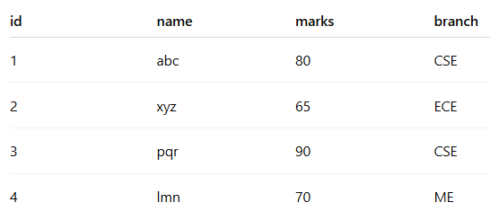.

- Show branches where average marks > 75.

- Show branches where number of students > 1.

- Show branches where maximum marks > 85.

Answers:
- Select branch from students group by branch having avg(marks)>75;
- Select branch from students group by branch having count(*)>1;
- Select branch from students group by branch having max(marks)>85;

